**S2D - SLUMS TO DEMOCRATIC**

A Course project report submitted

in partial fulfillment of the requirement

of

**SMART SYSTEM DESIGN**

by

**AREEFA (18K41A0505)**

**K. ANVESH (18K41A0525)**

**K. PRAGATHI (18K41A0528)**

**K. RISHITHA (18K41A0529)**

Under the guidance of

**Mr.Ch.Rajendra Prasad**

Assistant Professor, Department of ECE

&

**Mr.Y.Srikanth**

Assistant Professor, Department of ECE

**S2D (SLUMS TO DEMOCRATIC)**

**ABSTRACT:**

India is the biggest democratic country in the world which has taken giant strides in the last few decades and we are now the world’s sixth-largest economy. But in between this, we cannot forget everyday issues that still continue to pose hurdles in the progress of the nation. Though our country holds the title as democratic, there’s still a **communication gap** between the people and the government. This is the gap that is under covering and ignoring the sufferings of the people living in harsh conditions in the slums.

**OBJECTIVES:**

* The aim of this project is to implement a low cost, reliable, and scalable product that could stand as a support to the people in slums who are in need of food and even to remove the malaise of different problems like poverty, unemployment, illiteracy etc, which are becoming barrier in the development of India.
* Building the communication gap between the people and government and even among the people to experience and implement the real strategies of democracy by making India a better place to live in is the **main objective of S2D** (Slums to Democratic).

**BASIC IDEA GENERATED:**

In the olden days, there were telephone booths which were the major source to communicate with people in different regions. In the era of the development of technology in the communication field, these telephone booths were successful to a large extent. Today due to the influence and growth in technology, we rarely find them. Similarly in this era of development of a nation – India, here we come up with the same concept of STD telephone booths i.e., S2D smart helping booths which would be placed in the slums which bridges the gap among the people.

**WHOLE PROCESS IN A NUTSHELL:**

Now let us consider a major problem – food scarcity. For this, we have built the booth which consists of a fingerprint sensor. When comes to real time implementation, it would work with big data analysis of the aadhaar card basis. For demonstration, we have enrolled a few finger IDs through the Arduino software. Whenever there is a need for food by the slum resident, he/she need to approach the booth and scan his/her fingerprint. Once the fingerprint is detected, the ID would traverse through a channel that would be present at the nearby NGO. The alarm would ring so as to caution the NGO person. Thus, once the NGO person identifies the fingerprint ID in the channel, the immediate action would take place.

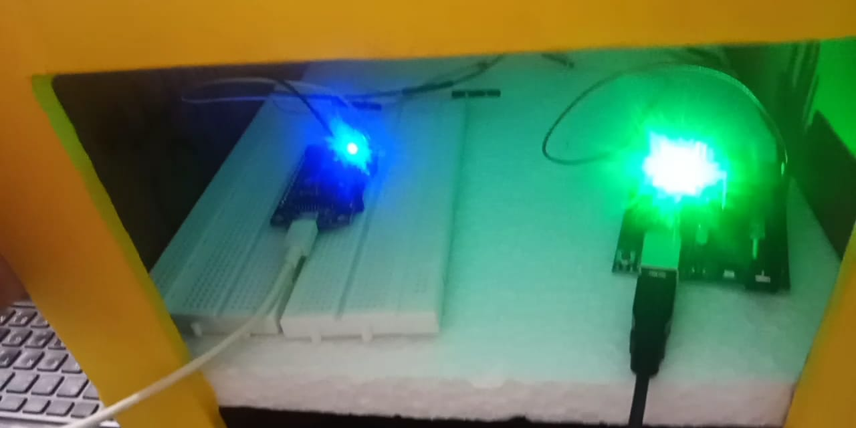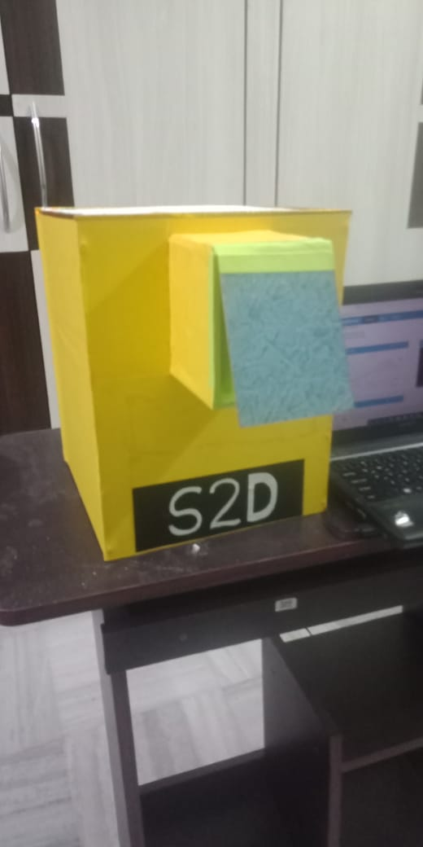

**OUTCOMES:**

* Through these smart helping booths we can generate great support from the government and NGOs to the people living in the slums and by this poverty levels would be decreased.
* Food that is being wasted adequately in the cities at different circumstances like functions, restaurants, can be communicated to the NGOs so as to supply to the need with the help of S2D.
* We can create employment opportunities for the youth present in the slums who can be able to transport the food from the NGO’s to the slums and can organize the marketing things.
* Even another form of employment like photographer and videographer can be generated so as to capture the emotions of the slum people when they receive the food and later send these clips to the donors so as to assure that their donations are reaching the needy.
* As the S2D booth requires network support, we can help in digitalizing slums to an extent.
* The bonds with the IT sector can be maintained so that they could contribute to donating the electronic goods which in turn help in inculcating the skills in the people living in slums. Thus, literacy levels would be increased.
* The equipment which is used in the smart booth is affordable and can be flexible in implementing in slums.

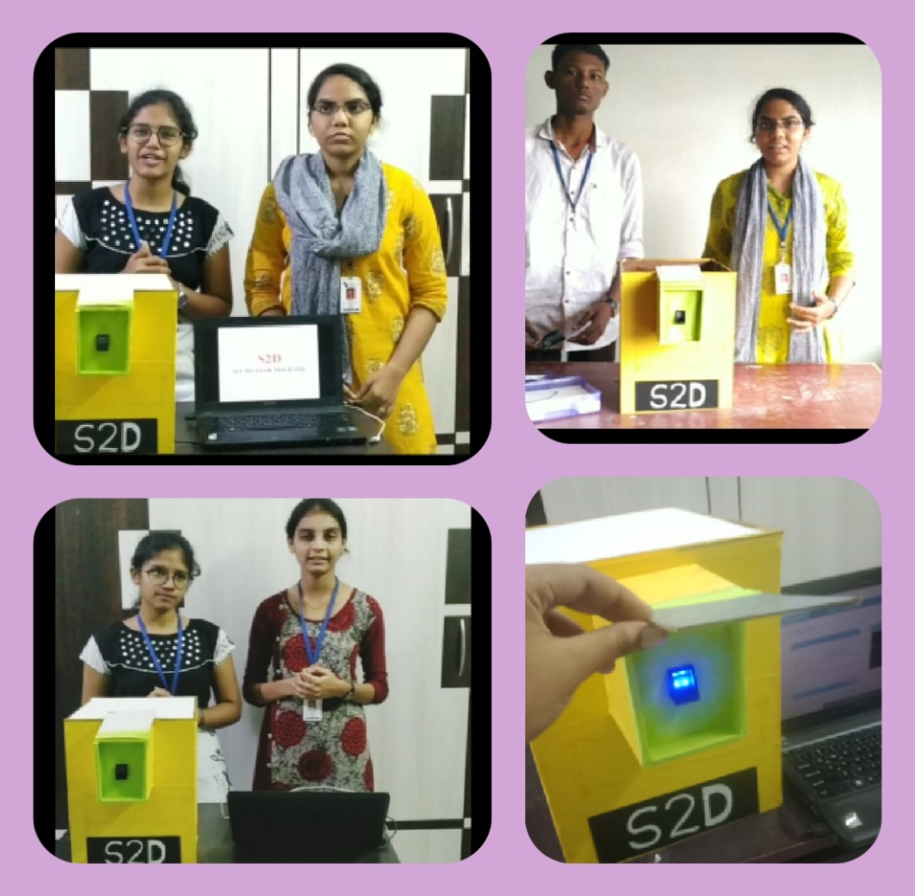

**FUTURE ADVANCEMENTS:**

We believe in interpreting technology as an implementation tool not only the learning tool. Thus whatever we learn, we will definitely implement for good cause.

With the help of technologies like- Machine Learning, AI, Deep Learning and even IOT to the most extent so as to advance the model to overcome the security issues and even in the field of the health care system in slums.

**CONCLUSION NOTE:**

At last, we would conclude that this would be even a great start-up that would really bring changes in the present circumstances as it is related to the nation’s development and aims to **transform millions of lives.**

India is being ruled by the people’s government and this power of unity is one of the greatest powers. Let’s utilize this power to the maximum extent to tribute our mother nation by our contribution. Everyone has the right to live and we have the right to contribute to transforming the lives by uplifting them by S2D (Slums to democratic).